**Video Annotation Tool**

**Customer Interface Lab © 2012**

**Introduction**

The Video Annotation (VA) software application is a tool that allows the user to draw the shopper’s path on the store’s floor plan while viewing a first-person eye-tracking video. The process usually consists of the following steps:

1. Open an existing store floor plan pre-populated with fixtures. Alternatively, the user can open a new project and create a store floor plan and fixtures from scratch.

2. Open an eye-tracking video associated with a shopper’s trip from the File menu.

3. To create a new path, select the **Path** tool from the toolbar and start clicking in the drawing area to mark the approximate location of the shopper within the store.

4. As the video plays back, keep marking the position changes. The tool automatically connects the waypoints (circular nodes) and associates them with the current time in the video.

**The start time for each waypoint is taken automatically from the video. Please mark the end time for each product interaction or purchase by pressing F2, tick off the appropriate “shopped” or “purchased” checkbox, and use right mouse button to set the orientation the customer was facing at the time of the interaction.**

**User Interface**

The visual interface as presented in the image below consists of four main areas: the drawing area, video area, path list and Field Editor. They are described below along with the toolbar and menu.

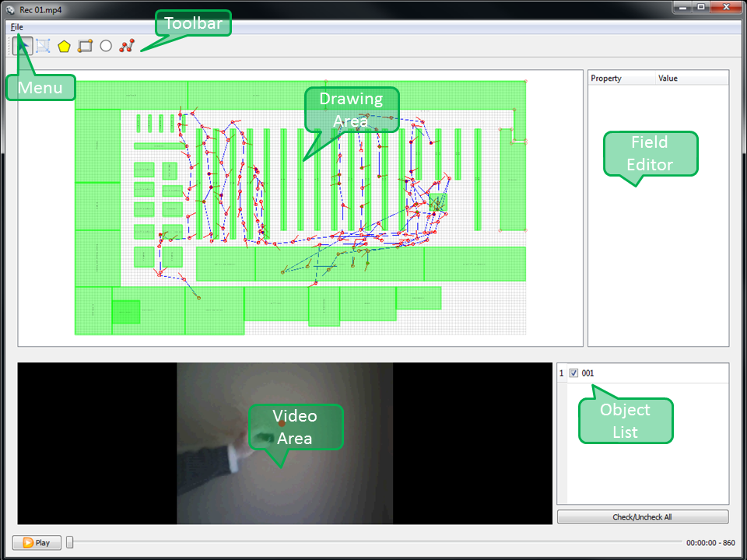

**Menu**

Load or save the annotation map. (Ctrl+O, Ctrl+S)

You can also load individual shopper video files. (Ctrl+L)

**Toolbar**

**Select:** Mouse click to select an object and edit its fields in the Field Editor. In Path and Polygon, you can select individual points.

**Path:** *Path is not related to the floorplan, but represents the individual shopper events and tracks.* Left click to add points. **Shift+click** to start a new path. **Ctrl+Click** inserts a node betweenthe two existing nodes. Every left-click creates a new node, with a right-click choosing the shopper’sorientation.

The path as a whole has these attributes: tags, description, and TripType. TripType can be one of: *stock up, fill in, routine and occasion*.

A path consists of waypoints connected by straight lines. Each waypoint has the following attributes associated with it: startTime, stopTime, category, purchased, shopped, phone, employee. The ‘Category’ combo box can assign a product category to the current location of the customer. You can either select one from the list or type the first few letters of the category name to search.

Start time is automatically taken from the video when the node is created. Stop time is set to start time. Start/Stop times can also be set to the current video time by pressing **F1** or **F2.** Purchased **(F3)**, shopped **(F4)**, phone interaction **(F5)** and employee contact **(F6)** are checkboxes to tag special event types. Use the tag “shopped” to indicate that the shopper looked at products in the category for more than 4 seconds and/or touched one or more products. Selecting an individual point queues up the video to the point’s timestamp. Press **Delete** to delete a selected point. Deleting the last point deletes the whole path.

**Edit**: In this mode, you can move and resize scene objects with a mouse. Drag the bottom right part of the object to resize. **Ctrl+click** to insert additional points. For Polygon, click and drag to move existing points. You can also **Alt+Drag** objects to create a copy.

Press **Delete** to remove objects from the scene.

**Polygon:** Click to add points. **Ctrl+click** to start a new polygon. Press **Delete** to delete a

selected point. Deleting the last point deletes the whole polygon.

**Rectangle:** Click and drag to create a rectangle. The id will be displayed in the center.

**Ellipse:** Click and drag to create an ellipse. The id will be displayed in the center.

**Label:** Click and type to create a text label.

You can change the font size for floorplan objects either by modifying the font property in the

field editor or by using **Ctrl+/Ctrl-** shortcuts to increase/decrease the font 10% for the selected

objects

**Drawing Area**

The drawing area and video area can be resized by dragging the splitter between them. Use the main area to draw the floorplan and shoppers’ paths. The objects snap to the grid. The area can be zoomed in and out with a mouse wheel (scroll pad). It can also be panned when the cursor shows a hand.

If the cursor is an arrow, it is over an object which can be selected.

**Video Area**

Play/pause video or use the slider to jump to a specific time. Time is shown on the right. **Space** anywhere in the window to play/pause. Press **Ctrl-R** to enter the video playback rate: from 0.2 to 100 (1 is normal speed). Press **F11** to toggle video view between normal and maximized. Use **left/right arrows** to REW/FF **1 sec** and **Ctrl+left/right** arrows to REW/FF **5 sec**.

**Field Editor**

The Field Editor allows you to edit the attributes of each object. For "Path" objects, the time (video frame number) is taken automatically from the video.

**Object List**

The object list on the bottom right allows you to show/hide **Path** objects in the drawing area (checkboxes). You can also press **Delete** to remove selected objects from the map.

**Tabs/Working Modes**

The software has two major operation modes represented by the tabs at the top of the window: **Edit** - for data entry, and **Search** - for data/video search and extraction. The **Edit** tab is used to enter the floorplan and customer path data. The **Search** tab can be used to visualize or export the video segments or tabulated data.